**Project Report Template**

1.Introduction

*1.1 Overview*

Build a Lightning app, add tabs and customize page layouts.

Create custom objects and fields for the app.

Define relationships between objects.

Import data and test the app.

*1.2 Purpose*

An approval process in an automated process that approves records in sales force. When you build an approval process, you specify the steps necessary for approval. A given step can apply to all records or just records with certain attributes.

2.Problem Definition & Design Thinking

*2.1 Empathy Map*

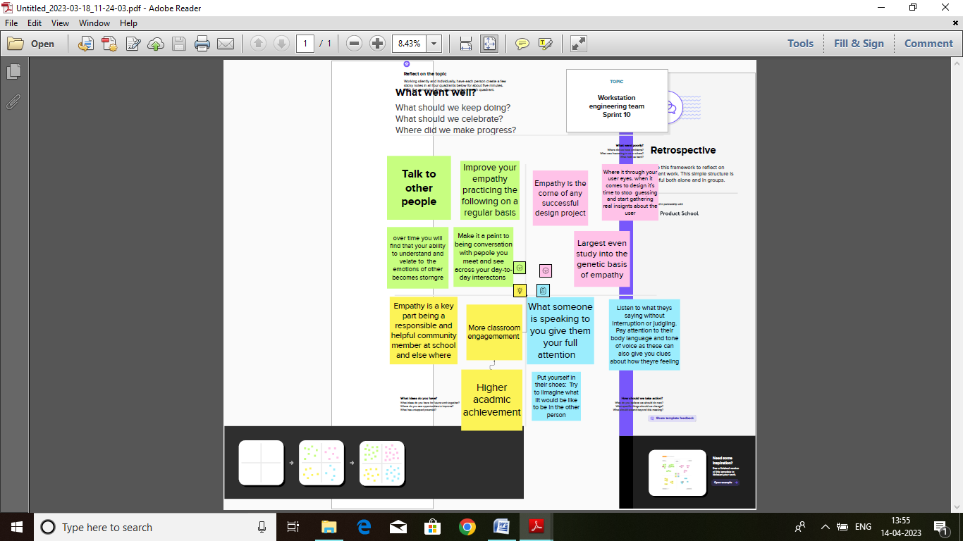

2.2 Ideation & Brainstorming Map

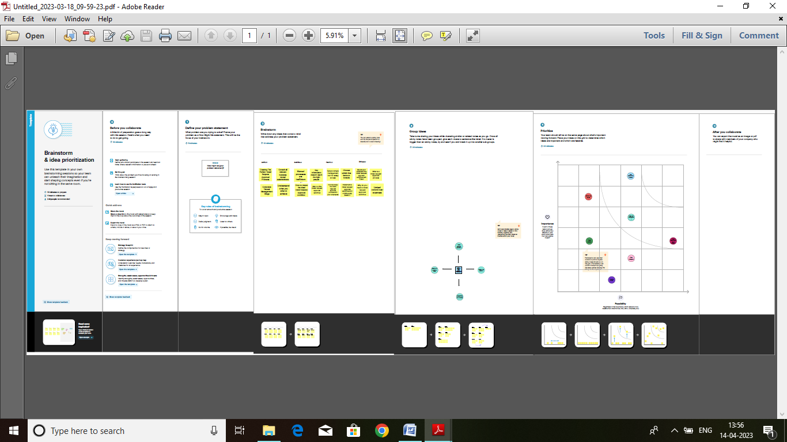

3. Result

3.1 Data Model:

|  |  |  |  |  |
| --- | --- | --- | --- | --- |
| Object Name | Fields in the Object   |  |  | | --- | --- | | Field label | Data Type | | |
| Department | Value | Select department |
| Travel Approval | Travel applications app | Auto Number |
| Expense Item | Travel approval | Travel Approvals |

*3.2 Activity & Screenshot*

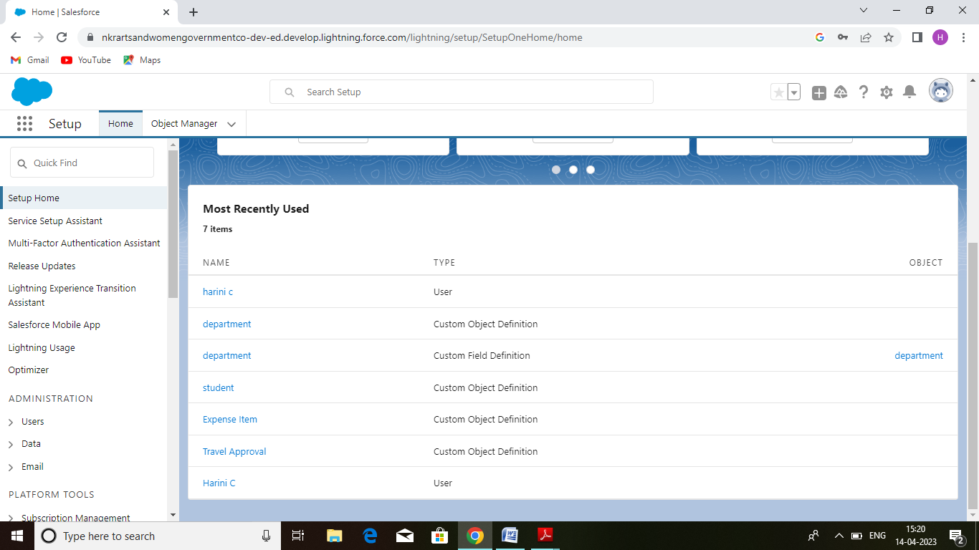

4. Trailhead Profile Public URL

Team Lead

Jothi M :https://trailblazer.me/id/mjothiibscphys-iitm

Team Members

Diviya V :https://trailblazer.me/id/rrevathi15

Harini C :https://trailblazer.me/id/harinic2

Joshika S:https://trailblazer.me/id/joraj10

5. Advantages

Life Insurance*:* Supplied through Metlife. Provides 2x the amount of eligible pay and maxes out at $1.5 million.

*Short Team Disability* : For most employees, it will cover 80% of on-target earnings, up to $5,000 per week.

*Long Team Disability*: For all employees, it will cover 66.67% of on-target earnings. The duration of the plan, and the extent of coverage after returning to work, varies widels.

Disadvantages

Each employee must submit an electronic request in the system for future travel.

Each request includes a list of estimated expenses for airfare, hotel, rental car, and so on.

Each request must be approved by the employee’s manager, and all out-of-state travel must be approved by a travel coordinator.

6. Applications

Defining the Use of an External Web Browser. Starting the sample Application. Logging in as an Employee for Requesting a Business Trip. Entering a Travel Reques....

7.conclusion

Information about the employee requesting travel including name, email, department etc. Details about the travel being requested including destination, estimated expenses. Business purpose for the trip. Line items for each part e.g. flight, rental car, hotel etc.

8. Future Scope

The Travel Requisition Approval & Expense Form must be completed prior to employee travel on state-related business.